How to make an order on the Local Food Coop website

Note: this document describes how to make an order on the Local Food Coop website. You need to register before making an order for the first time – see the “How to register on the LFC website” document for more information. Read below to find out how to make order.

Go to the website
Click the link below to open the LFC website in your web browser:

http://localhost/foodcoop/shop

You should see a webpage like this:

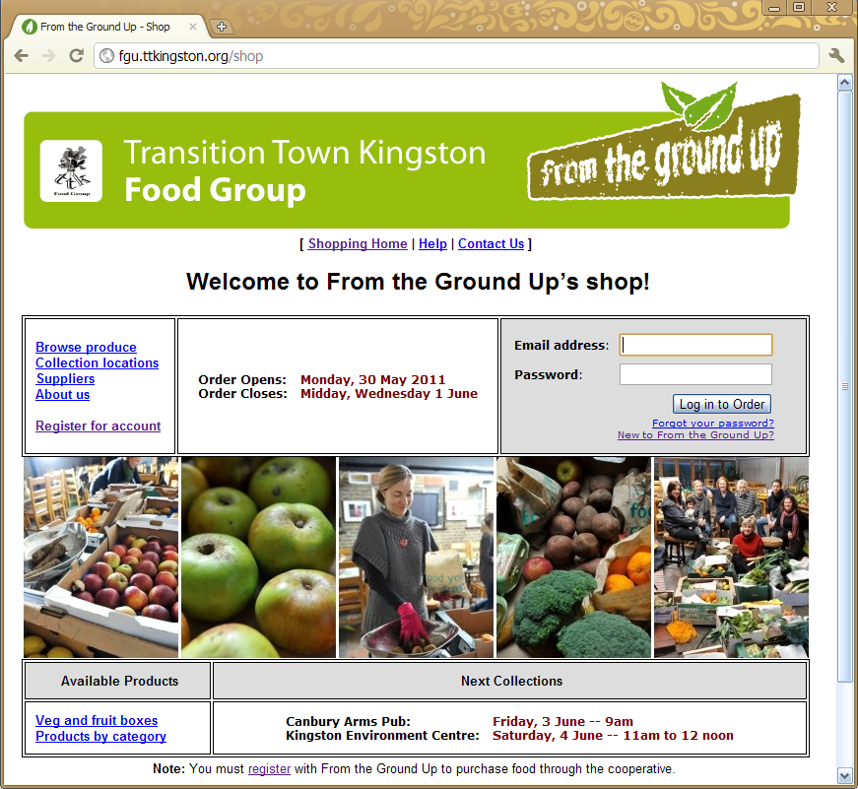

Log in to the website
Go to the grey login box on the webpage and enter the email address and password that you registered with. Then press the “Login to Order” button:

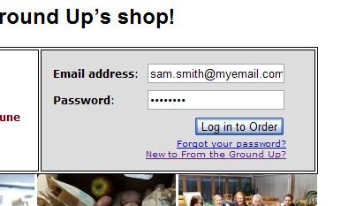

Choose your collection location
Select the location from where you will collect your order, and press the “Click to Start An Order” button. This will open your order, allowing you to add products to your shopping basket.

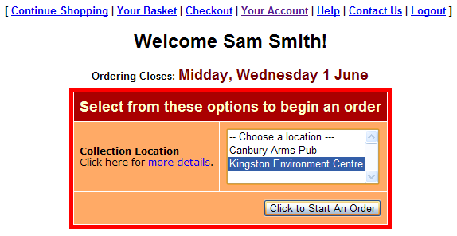
Choose pickup location

Add products to your shopping basket
Click on “Products by Category” to select food to add to your basket, as shown below.
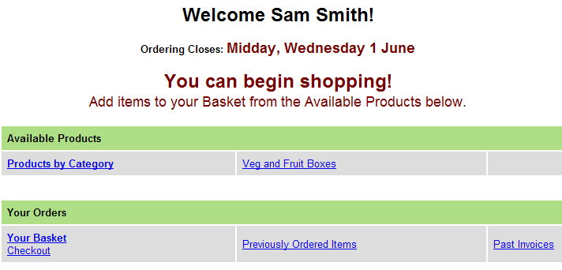

You will then see a list of products with an index at the top. To find products, either click on the relevant category in the index, or scroll down the product list:
Product index
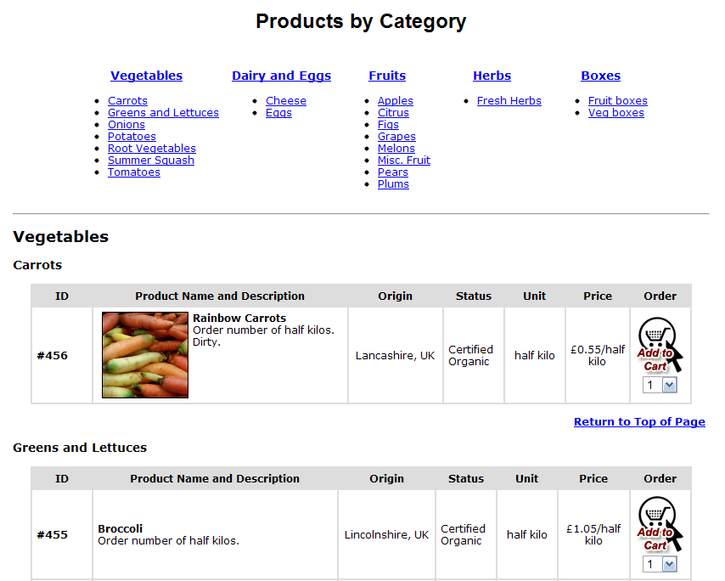
Product list
Once you have found a product you want to order, select the quantity, and press the “Add to Cart” button. This will place the product in your shopping basket:

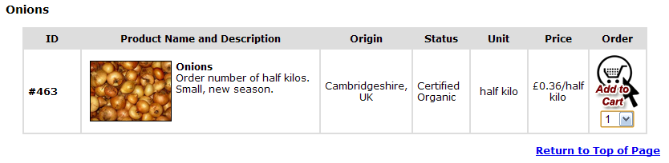
Select quantity and click “Add to Cart”

Continue adding products to your shopping basket until you have selected all the products you want. (You will be able to remove products from your shopping basket or change quantities later.)

Go to the checkout and submit your order
To visit the checkout, click the “Checkout” link at the top or bottom of the page:

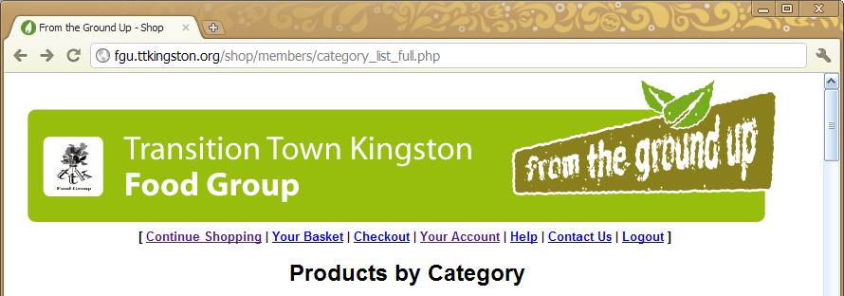
Click here to go to Checkout
Top of page

…

… or click here


Bottom of page
Once you are at the checkout, submit your order by pressing the “Submit Order” button, as shown below.

You can also review and update your order. To remove a product completely from your shopping basket, press the “Remove” button. To change the quantity of a product, enter the new quantity and press the “Update” button.

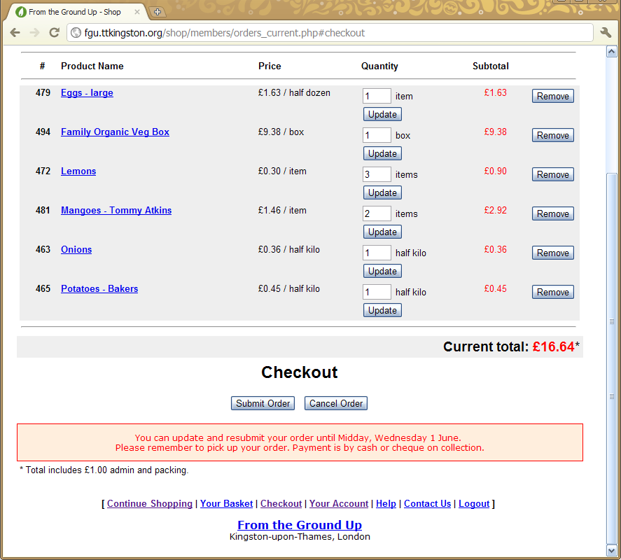
Submit your order!

That’s it! Once you submit your order, you will receive a confirmation email with invoice.

You can revisit the website and add or remove products as many times as you like up to the ordering deadline. Remember to resubmit your order after making any changes! You can also cancel your order any time up to the ordering deadline.

